**Week 7 Diary**

**📝 Plan:**

1. Randomly generated coins on maps.  ✅

2. Updated sprites ✅

3. Fixed a serious fault on random generator ✅

4. Fixed other display and interactive errors ✅

5. Achievements still not completed. ⚠

**🚫 Problem:**

In LPC1768, due to the lack of real-time clock, rand() function shouldn’t be used to generate random numbers, even adding “srand((unsigned)time(NULL));” makes no difference. This problem was found when noticing whenever I restart the processor, those coins which should be scattered randomly on maps only appeared on fixed points.

This issue can be solved by introducing “analog.read()” to simulate random events.

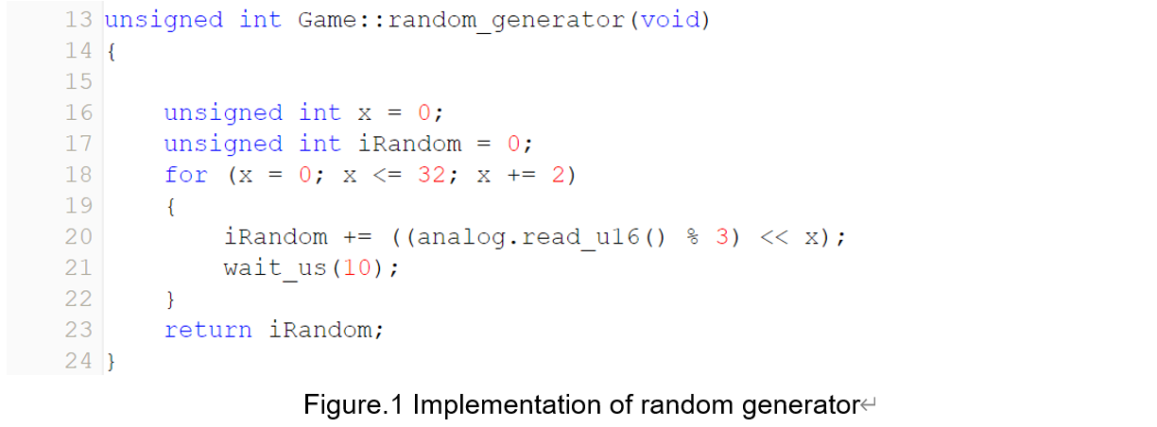

**🎁 Outcome:**

1. Random coins (Fig.2)

Coins scattered on random positions when you try entering a map again. In future, there’ll be random respawn points, success points, even random maps.

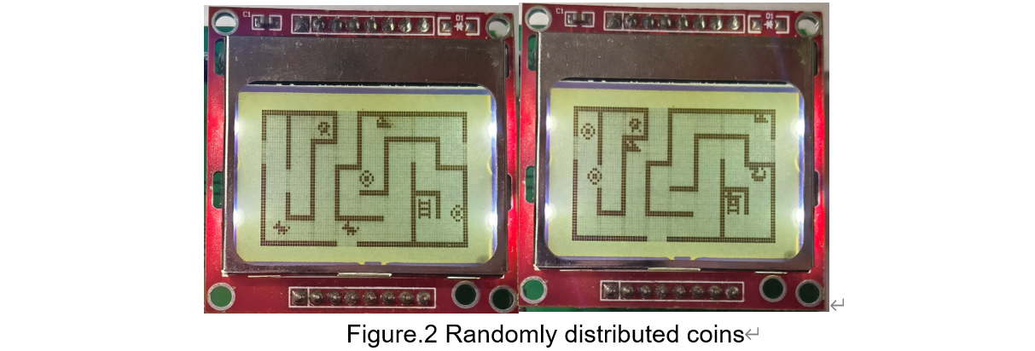

Codes are shown in Fig.2-x.

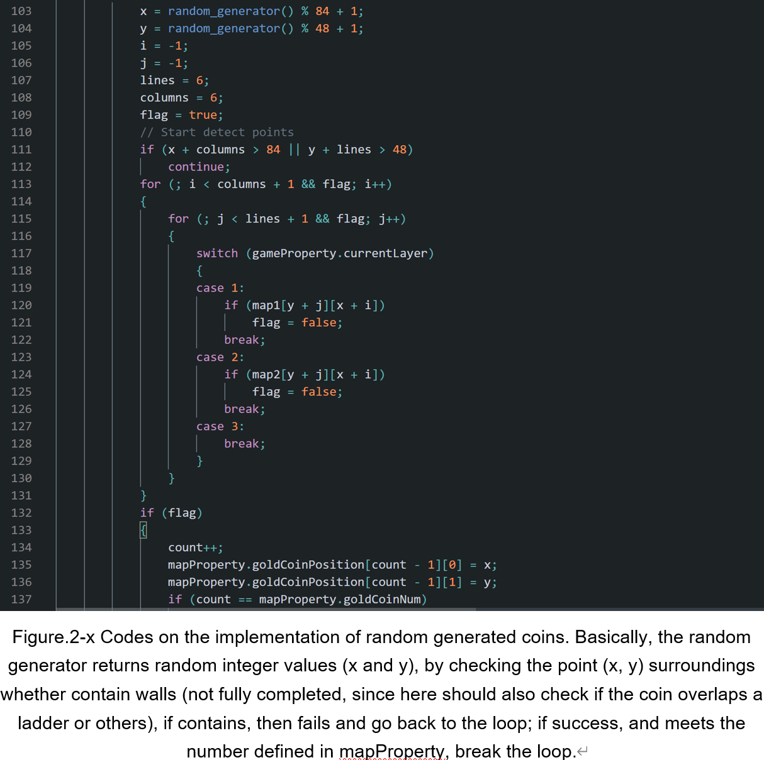

2. Updated sprites (Fig.3)

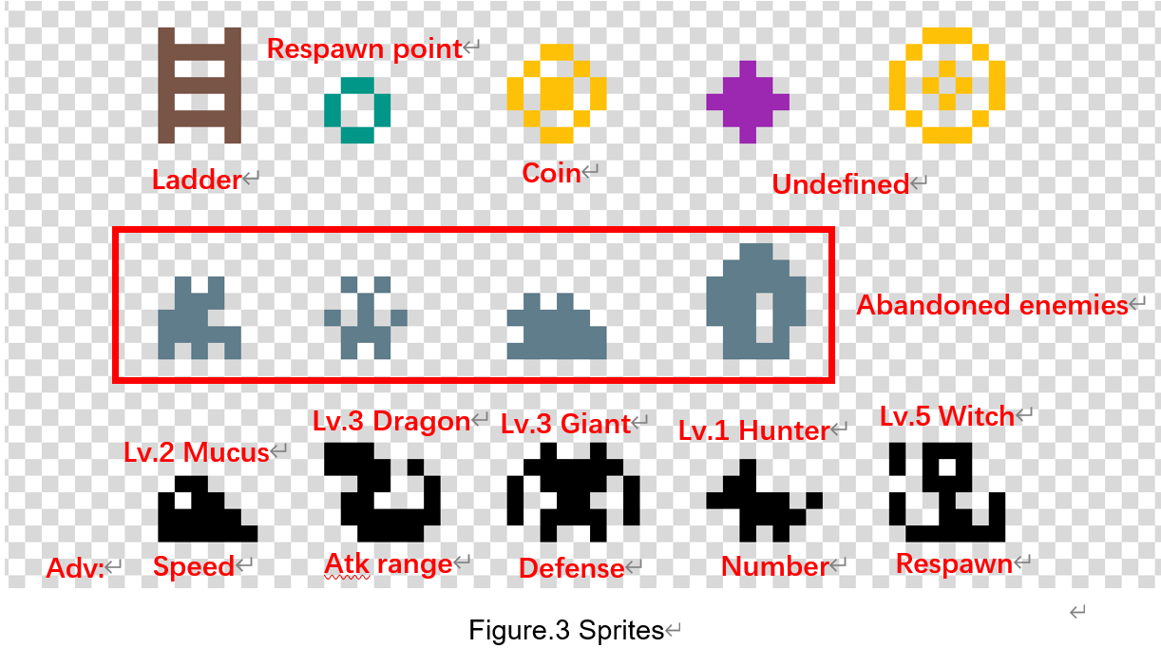

3. Other structural modifications.

Only in the Game.cpp, there are 1617 lines.

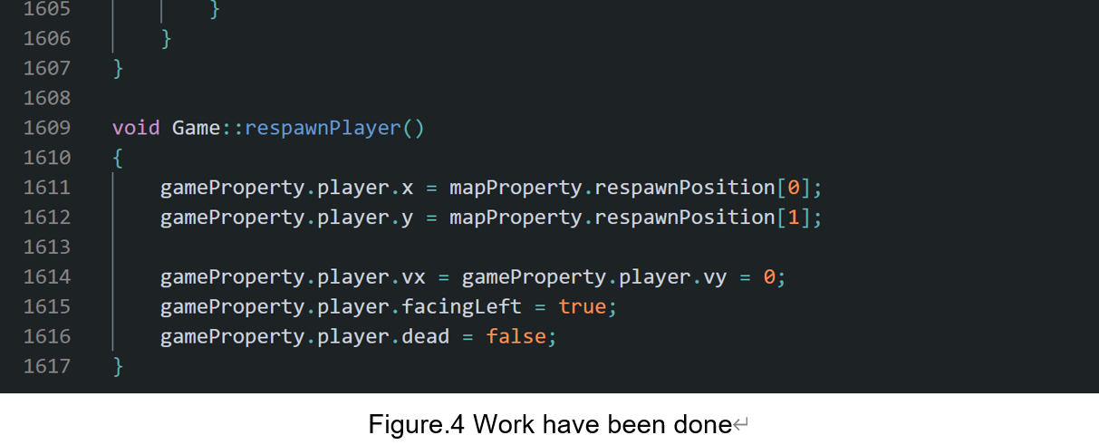

4. Others.

‖ Now ladders and chest will be displayed in a proper position.

‖ Now player will not unlock a chest or get a coin simply go close to it, button B is introduced and should be pressed as the interactive button.